**Experiment 7:**

**Aim: ALP to transfer n block of data from one segment to another segment.**

**Code:**

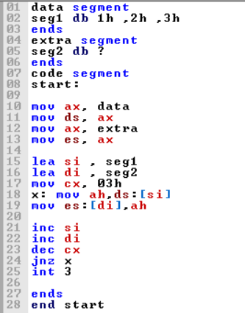

**Output:**

